**Installing MySQL, SQL Developer, MySQL JDBC Connector**

1) MySQL 8.0 download:

<http://dev.mysql.com/downloads/mysql/>

1. Scroll down to the bottom of the 'Download MySQL Community Server page'.

2. In the 'Select Platform' selection box, choose your particular OS.

3. For Windows, download the MySQL Installer

For Mac OS, Mac OS X 10.9 (x86, 64-bit), DMG Archive

**\*\*Note: During installation, if you're asked to provide root login name and password, provide them BUT MAKE SURE you remember what you entered\*\***

1.a) Installation references:

Mac : <https://dev.mysql.com/doc/refman/8.0/en/osx-installation.html>

Windows: <https://dev.mysql.com/doc/refman/8.0/en/windows-installation.html>

After installing mysql do the following to make sure it is working:

Add the following to .bash_profile file:

export PATH=$PATH:/usr/local/bin

alias mysql=/usr/local/mysql/bin/mysql

alias mysqladmin=/usr/local/mysql/bin/mysqladmin

Then run the following command:

$ mysql –u root –p

Enter password:

You should get mysql prompt

mysql>

Then type the commend below:

mysql> select now();

It will return the current date and time

1.b) Startup document

<https://dev.mysql.com/doc/refman/8.0/en/osx-installation-notes.html>

<https://dev.mysql.com/doc/refman/8.0/en/invoking-programs.html>

2) Install Oracle SQL Developer

<https://oracle-base.com/articles/mysql/mysql-connections-in-sql-developer>

<http://www.oracle.com/technetwork/developer-tools/sql-developer/downloads/index.html>

3) Download MySQL JDBC Connector

<http://dev.mysql.com/downloads/connector/j/>

From Oracle SQL Developer Tab => Preferences => Database => Third Party JDBC => Add Entry => add the jdbc connector jar file => OK

Add New Connection (Green + sign under Connections) => give a Connection Name, Username as root, and a blank password, then hit “Save”. Hit “Connect”. Enter the password created in step 1a.

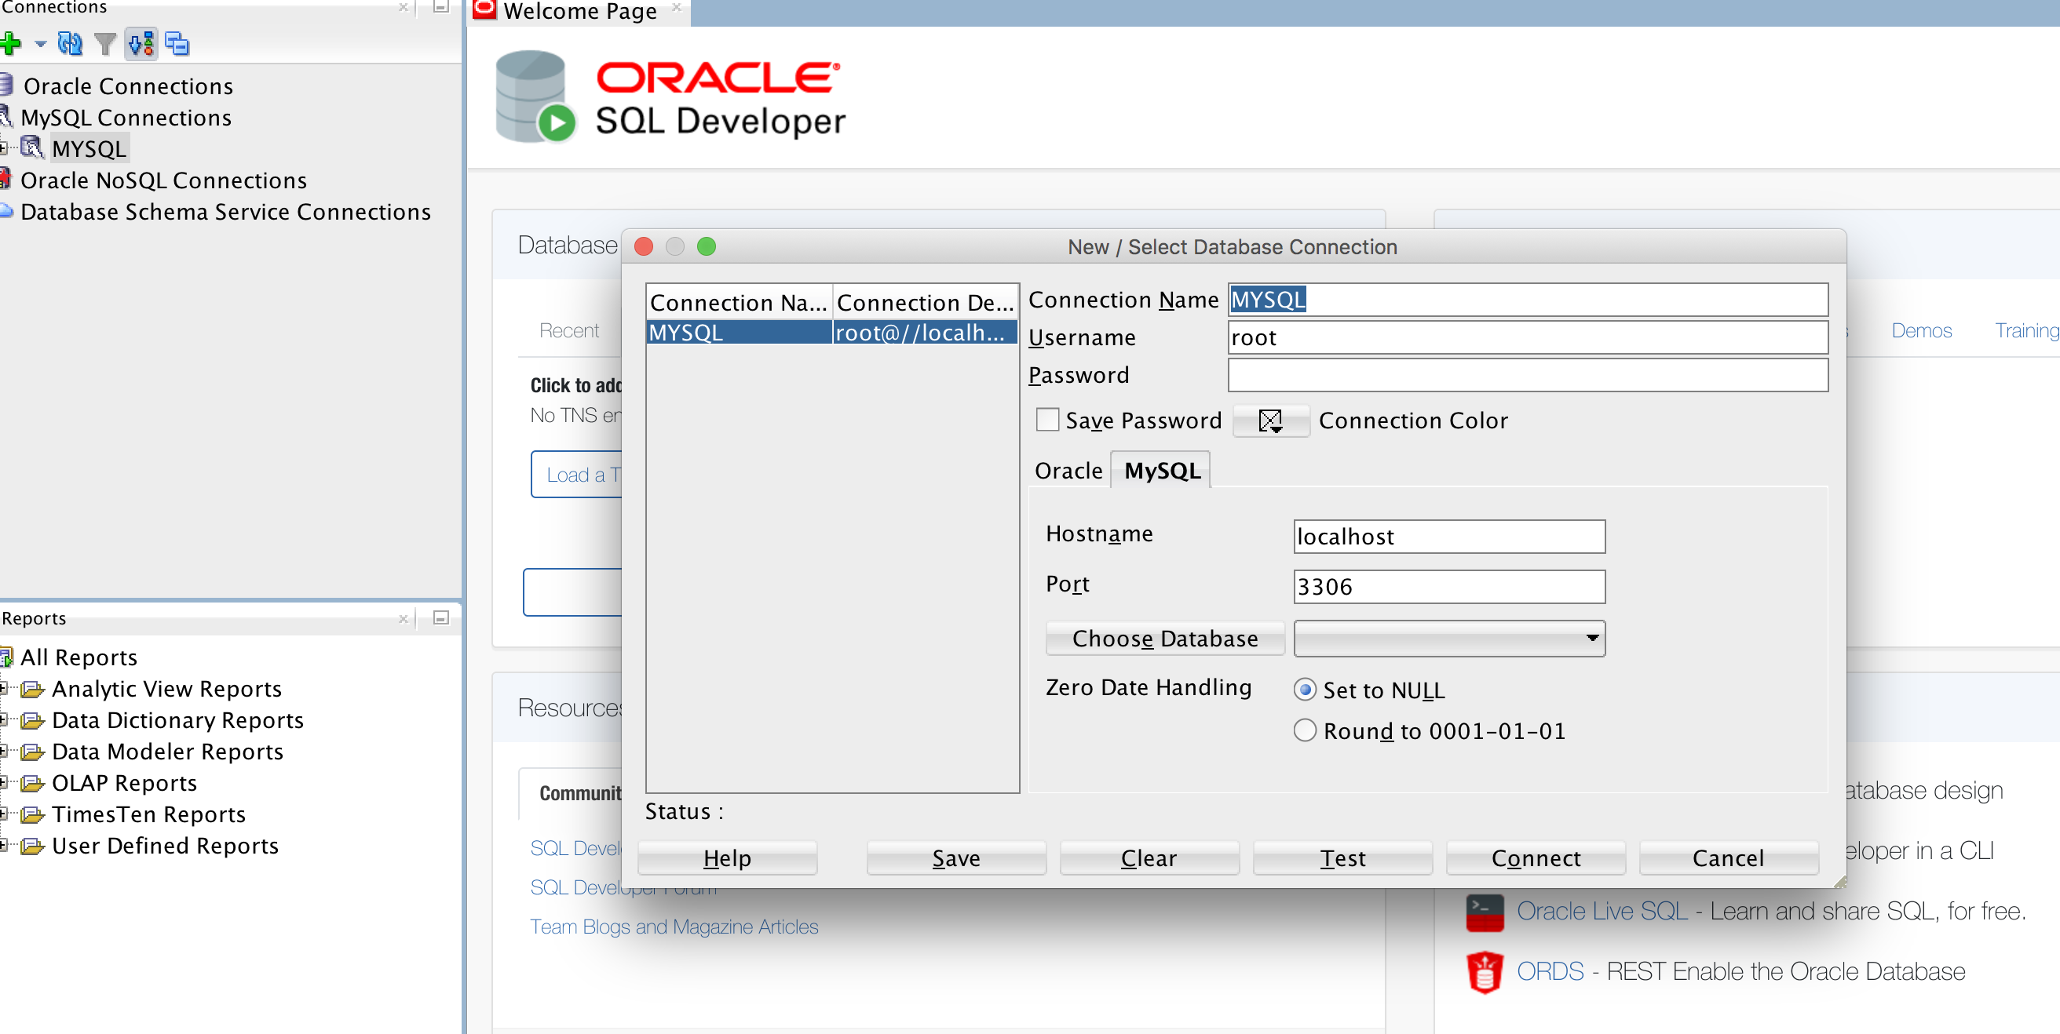

# Right-click the connection and click “Open SQL Worksheet”. Then run the select now() from sql developer

# 

# 4) Java Database Connectivity with MySQL using eclipse

<https://www.javatpoint.com/example-to-connect-to-the-mysql-database>

Any hiccups with this process, refer to the following link:

<https://stackoverflow.com/questions/2839321/connect-java-to-a-mysql-database/2840358#2840358>

